**Hamza Rahman**

**3381991601**

**Creative Computing Project**

**INTRODUCTION:**

In developing my game,An existing source code provided me with a strong foundation and a wealth of inspiration. This allowed me to start building my own original vision from the ground up. I was aware of the benefits of utilising previous work, so I made sure to pick a project that matched my conceptual objectives and offered a strong, flexible foundation for future creativity. Not only do I want to improve upon what has already been done, but I also want to add a lot of new features to the game and make it uniquely my own. Some have been inspired from my previous module (introduction to programming) where I first started experimenting in game development by creating a 2d platformer using javascript. I had also created custom assets that would be seen through my final project, some were cut out of other completely free assets and some i created on my own using MS paint. My goal is to create a game that stands out in the competitive independent game market while simultaneously striking a deeper chord with players through the integration of these distinctive elements. This tactical strategy, which builds on a tested basis while injecting new, imaginative ideas into the project, perfectly captures my notion of marrying innovation with dependability to enthral and involve the gaming community.

here is the original code that has helped me to build up to my own game : <https://codeheir.com/2021/07/25/how-to-code-a-top-down-shooter-%F0%9F%94%AB/>

<https://www.youtube.com/watch?v=tkt_mAzdU_c>

source : konita & luke carrigan

**HOW MAX SLINGER RELATES TO THE THEME OF INPUT AND OUTPUT:**

Implementing the theme of INPUT/OUTPUT my game named Max Slinger, where the protagonist destroys waves of aliens, offers a unique opportunity to explore various facets of communication between computational systems and players, as well as among the game elements themselves. Here are some ideas on how to incorporate the theme:

Physical and Conceptual Connections:

Physical: Implement physical interactions beyond traditional game controls. For instance, using the classic WASD and mouse movements

Conceptual: The game's narrative could involve Max Slinger hacking into alien technology or systems as part of gameplay, requiring the player to solve puzzles or make decisions that affect the game world, adding depth to the INPUT/OUTPUT theme.

**Scales: Macro to Micro:**

Macro: The game could zoom out to a strategic level where the player must survive there way through an armada of aliens

Micro: On a smaller scale, individual enemy behaviour, bullet trajectories, and environmental interactions can provide immediate, tangible feedback to player actions, illustrating the cause and effect of every input.

**Merchandise Concept:**

Here is the concept piece I created in order to see how this would be formatted into an actual game and granted there is not much to look at as I was given a limited time frame to work on however it did do the job.

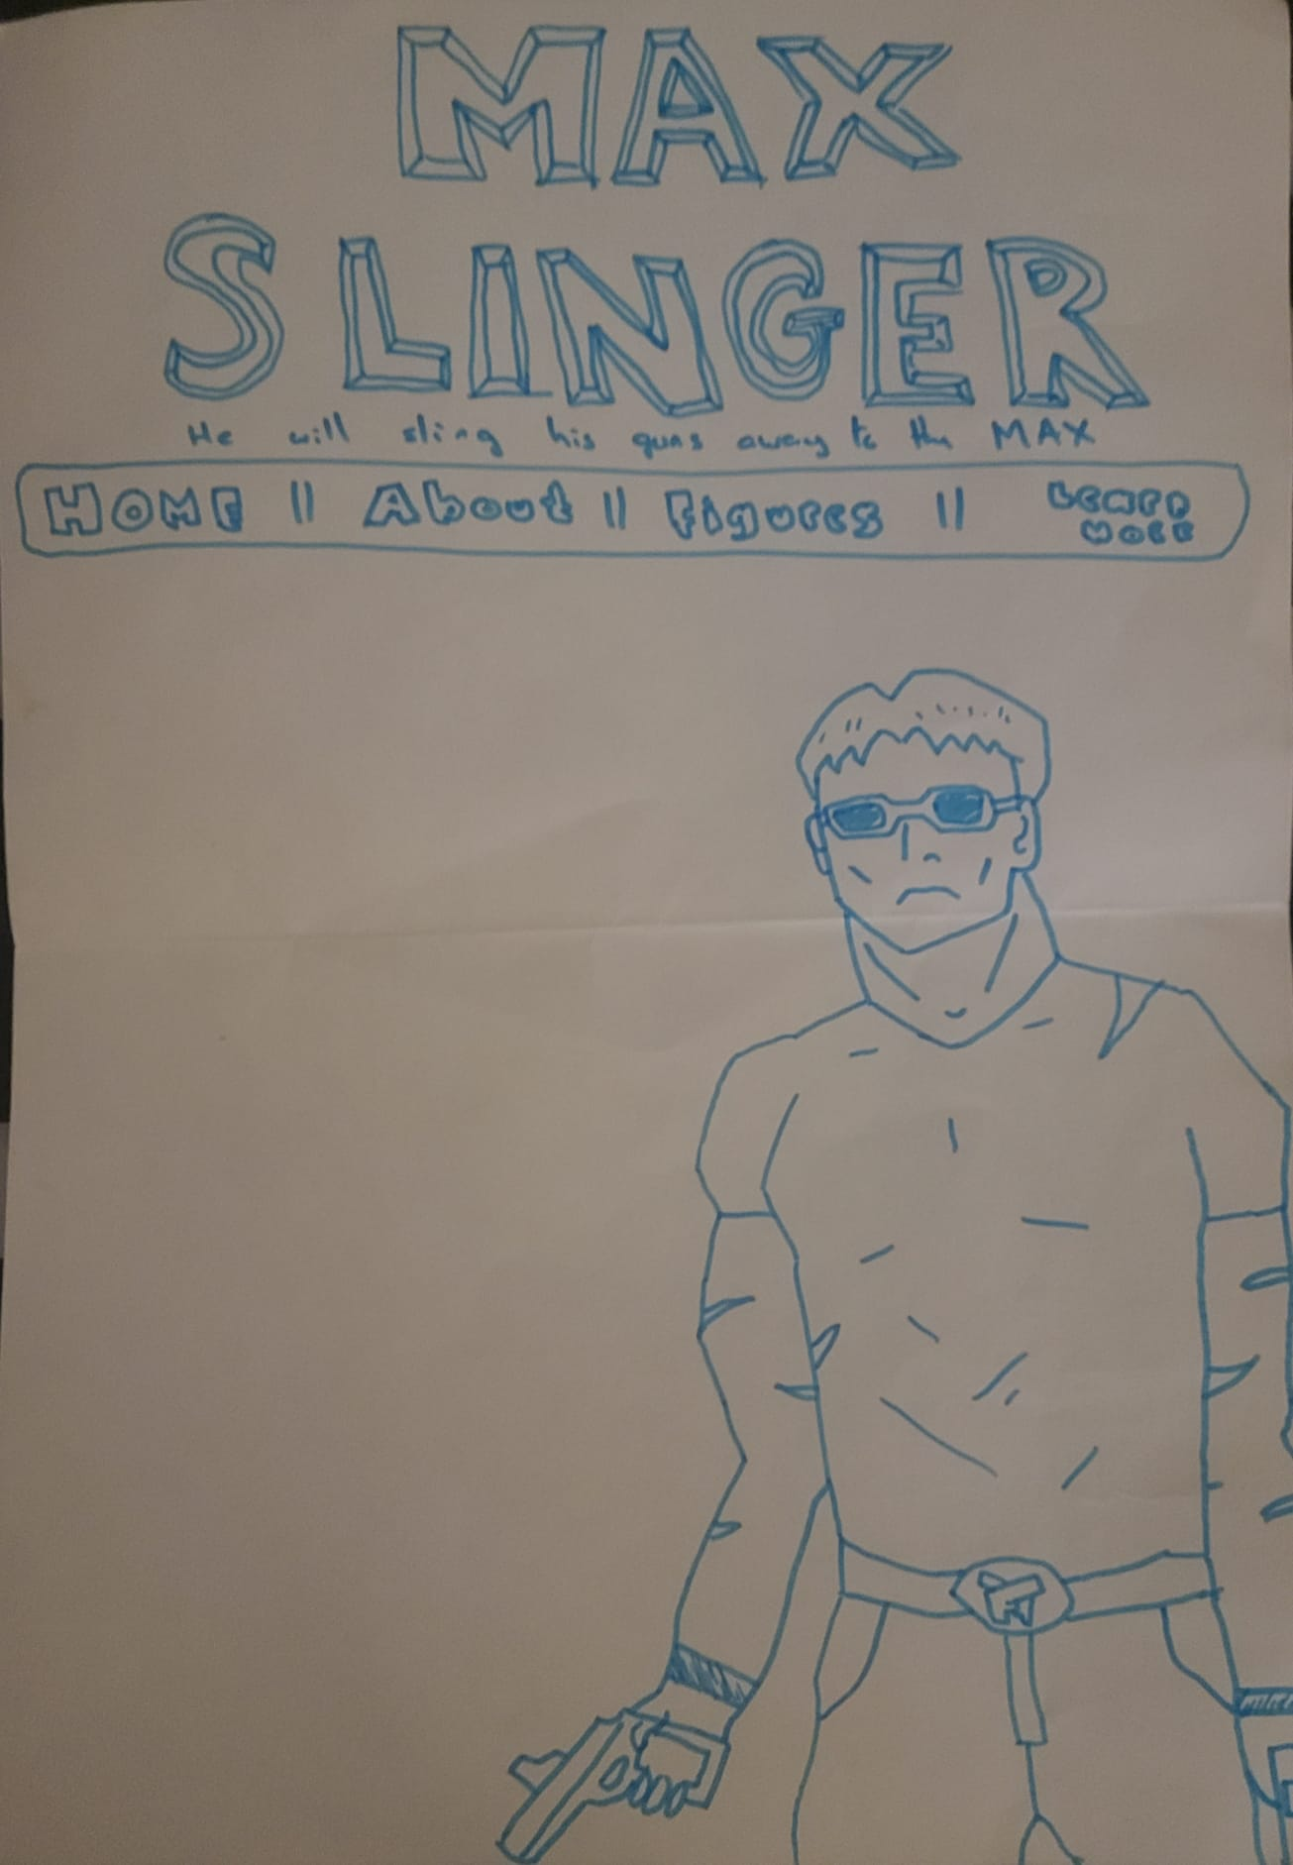

As you can see this piece only displaces Max Slinger with a gun and with a Nav bar that would've been implemented in a previous website which would have shown Max Slinger as a multimedia franchise.

**Final Concept:**

Here is the final piece that has been Made by my brother @fourtyfingers on twitter. This was the kind of advertising i had been envisioning if i were to go use another suitable game engine and go all out however the image seen below already describes what i wanted Max Slinger to become



There would be a tonne of awesome stuff if it was designed for Max Slinger. People would see his visage and a snappy saying on t-shirts everywhere (an example provided below), proving to others that they too can be tough. On shelves would be little figurines of Max in his action position, encouraging others to have courage. Wall-mounted posters with Max at the centre of the action would demonstrate how one person can have a significant impact. Max Slinger merchandise, such as toys and mugs, would be a great way to honour his life and inspire others to speak up for what's right.

